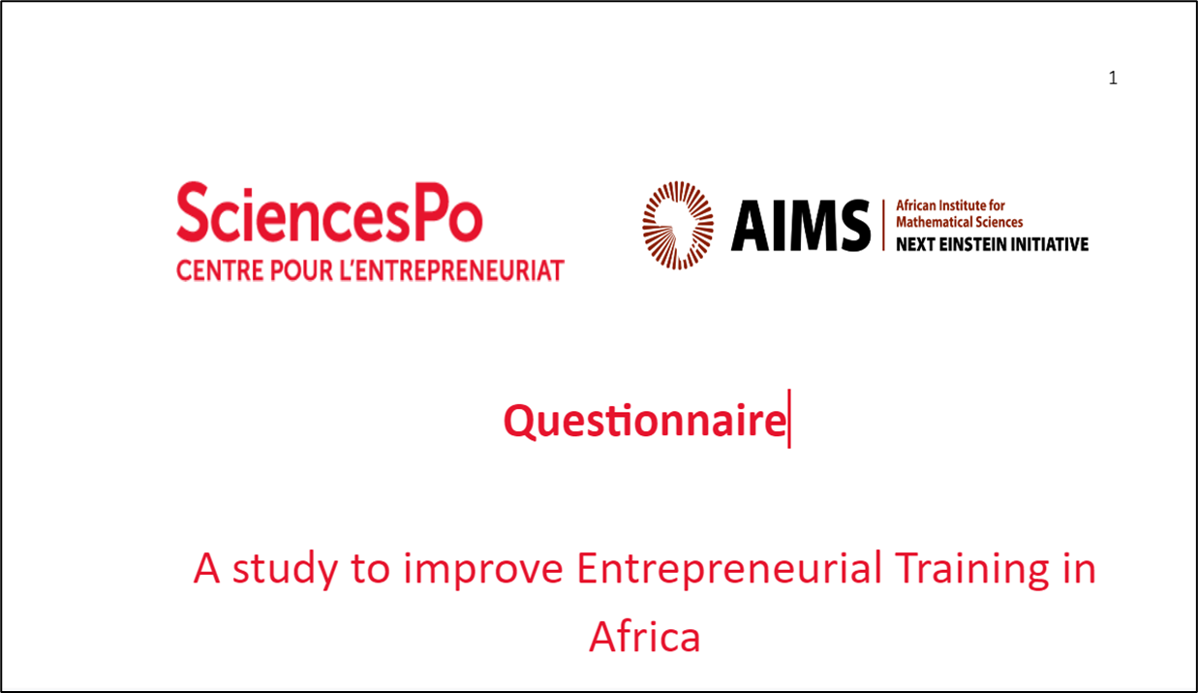

**Language elements | Sciences Po Alumni**

PROJECT BETTERING ENTREPRENEURIAL EDUCATION IN AFRICA (BETAF)

A project which focuses on Alumni entrepreneurial trajectories to help design the next generation of courses and support mechanisms for African entrepreneurs

**Entrepreneurship matters for Africa !** Especially, as it is expected to be the most promising sector to provide an occupation to the millions of young Africans who will enter the job market over the next decades. But also, because, it is hoped that, in that sector, they will best express their innovative and creative talents, create the much needed enterprises and jobs and, as a result, make Africa rise.

**For that scenario and its promises to materialize, it is important to work on its prerequisites** and build the conditions for young Africans to become successful entrepreneurs.

**Entrepreneurial Education, beyond access to financial resources and other constraints, appears to be one of the most critical challenges faced by young African graduates** who often start their entrepreneurial journey with a great deal of motivation. Yet, a lack of key managerial skills, limited knowledge of their business ecosystem and difficulties to build coalitions of partners are often synonymous with early failure for those entrepreneurs while, for African countries, those impediments slow down the development of promising entrepreneurial ecosystems.

**That is why the** [**Sciences Po**](https://www.sciencespo.fr/), the [**African Institute for Mathematical Sciences (AIMS)**](https://nexteinstein.org/) **and several leading African academic institutions, have teamed up and mobilized a 40 people research team to launch an unprecedented project aimed at Bettering Entrepreneurial Training in Africa** (the project is hereafter referred as BETAF).

Thanks to questionnaires administered to alumni from Sciences Po, AIMS and other African academic institutions, the research team will try to identify tangible or intangible assets, be it **skills, teaching techniques and support activities, capable of accelerating African graduates' entrepreneurial trajectories.**

**Alumni represent an excellent source of knowledge to improve entrepreneurial training practices** as those who chose to become entrepreneurs experienced the toughness of the job market, the requirements of professional life and daily entrepreneurial solicitations. Hence, their command of the know-how, knowledge, values and mindset that must be developed among future generations of Scholars.

After field visits and an intense analysis of national entrepreneurial training practices, **the research team recently reached a critical phase of the project: the validation of the questionnaire** that will be administered to hundreds of alumni in 5 countries - Cameroon, Ghana, Senegal, South Africa and Rwanda - representative of African diversity.

**Results will be shared in the upcoming months to alumni, academic institutions and decision-makers to prepare new curricula, policies and support mechanisms for the next generation of graduates.**

More information is available on the project website - [**www.betaf.info**](http://www.betaf.info) - while contacts for the project are listed below.

--------------------------------

| **SCIENCES PO**  **Jean-Paul MVOGO**  Lead Researcher  Sciences Po | Centre for Entrepreneurship | Sciences Po | 27, rue Saint-Guillaume | 75337 Paris Cedex 07 | France  Tel: +237 6 57 83 91 91  Email: [jeanpaul.mvogo@sciencespo.fr](mailto:jeanpaul.mvogo@sciencespo.fr)  Website: <https://www.sciencespo.fr/entrepreneurs/index.html> |  |  | **AIMS**  **Daniel Duviol TCHEUTIA**  Student Development and Cooperative Manager  AIMS Cameroon | South West Region, Crystal Garden | P.O. Box 608 | Limbe | Cameroon  Tel: +237 675 04 69 75  Email: [daniel.tcheutia@aims-cameroon.org](mailto:daniel.tcheutia@aims-cameroon.org)  Website : <https://aims-cameroon.org/> |
| --- | --- | --- | --- |